User Demonstration Guide
A demonstration of screenshots to show how to use the statewide and county-level tools. The notebook documents user workflow.

- Screenshot of Home Hub UI (choose statewide or county-level)
https://home-page-ev.onrender.com/
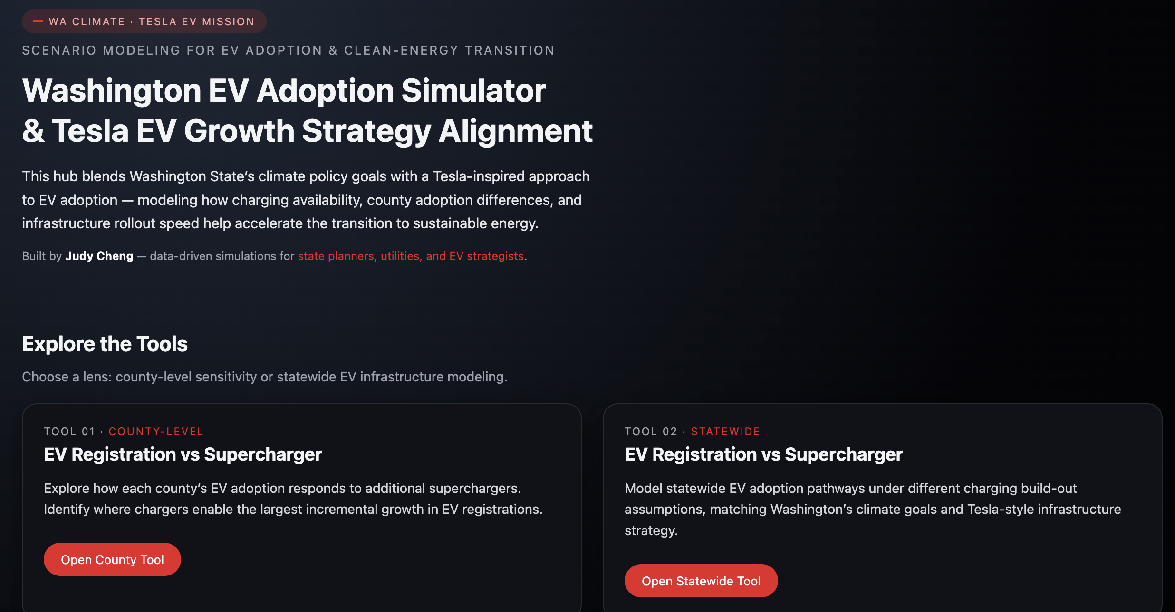

- Screenshot of Statewide Tool (user input year)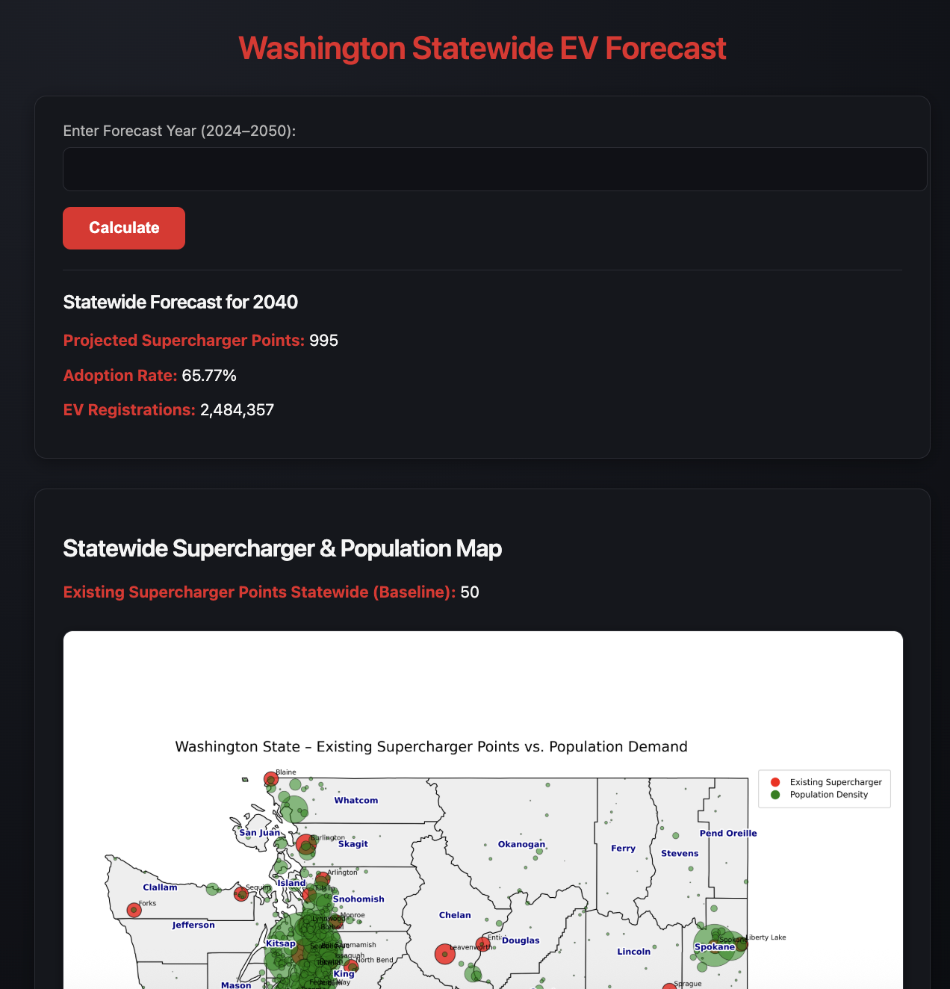
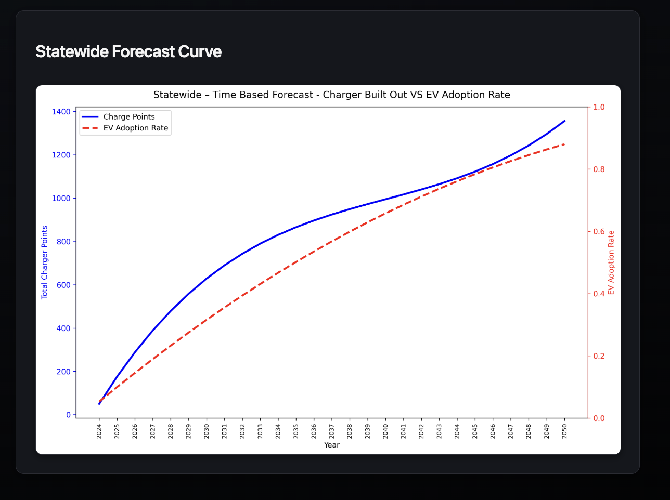

- Screenshot of County Tool (user input county name + year)
